REV. | Description | Date
00 | SPEC ISSUE  NEW MODEL:ADP-330HB BA | 05/11’23
01 | 102A-239282  Change ES. 2.2.4 ID resistor | 10/04’23
02 | 102A-241023  ADD MODEL: ADP-330HB BA88 | 01/09’24
03 | 102A-243132  1. DEL Mechanical characteristics Item 12 AC SOCKET TEST(非筒狀機種不適用) | 04/02’24
04 | 102A-244256  1. Item 2.2.2 Add new Peak load specification | 04/25’24
05 | 102A-245344  1. Change ES. Item 3.1.1 add description "Measure adapter’s temperature on Bakelite" | 05/31’24
MODEL LIST:ADP-330HB BA, ADP-330HB BA88
- GENERAL FUNCTION DESCRIPTION

(For reference only.) This specification describes a self-contained PFC 330.0 Watt AC Adapter, powered from the AC Mains, and supplying a single direct current, constant voltage output. There is no power switch. Output power is supplied upon application of AC input through the line cord. The output cable is 1.8m long with 3 conductors - one for output power positive and one for return. The third conductor will provide an “ADAPTER POWER RATING and ID” signal proportional to the output load current and output power rating.

- ELECTRICAL

  - INPUT

    - Voltage
The power supply shall be capable of supplying full rated output power over the input range of 90 to 264 VAC RMS. Nominal voltage is 120 VAC, rated voltage is 100-240VAC. The power supply shall be capable of start- up (power-on) at 90 VAC and 50 Hz minimum.

    - Power Factor
Adapter with PFC shall comply with harmonic input current requirements as detailed in EN61000-3-2 and JEIDA MITI standards. The harmonic input current requirements must be met under the following operating conditions:
Load Requirements: 100% and with output load set in order to have 75W input power.
Input voltage: 230Vac/50Hz.
For active power factor correction the power factor at 100% load shall be greater than 0.9 over the entire input 100Vac & 240Vac.

    - Range Switching
The power supply shall accept the full input range. No range switching is necessary or possible.

    - Frequency
The rated frequency is 50 - 60 Hz.
The supply shall operate with an input frequency of 47 – 63 Hz AC.

    - Current
Maximum steady state input current shall be less than 4.2 Amperes RMS at 90 VAC and maximum load.

    - Input Power Rating
(For reference only.) The supply true input power is less than 370 watts.

    - Inrush Current
Maximum inrush current, from power-on (with power on at any point on the AC sinewave) and including but not limited to, three line cycles, shall be limited to a 29% margin of the I2t rating of the input fuse and bridge rectifier:
      - Cold Start
Cool the disconnected power supply long enough to ensure that all components are within 3°C of the minimum temperature as specified in Section 3.1. Apply the maximum input voltage in section 2.1.1 to the power supply.
      - Hot Start
Operate the power supply the maximum ambient operating air temperature as specified in Section 3.1 for 15 minutes. Cycle power to the power supply by removing and reconnecting maximum input voltage as specified in Section 2.1.1.

    - Brownout & Brownout Recovery
- The adapter shall survive the application of the following tests at 25℃ ambient temperature 80% load
- Condition.
During the test the output voltage shall remain within specified limit until shut down the adapter.
No oscillate/fluctuate at any time.
      - Brownout Conditions
100Vac to 0Vac at 50Hz at fixed slope of 6.6V/min, back to 100Vac
      - Brownout Recovery Conditions
0Vac to 100Vac at 50Hz at fixed slope of 6.6V/min

    - Protection
      - Under Voltage
The power supply shall not be damaged by applying an input voltage below the minimum specified in Section 2.1.1.
      - Catastrophic Failure Protection
When any single component fails, the power supply will not exhibit any of the following effects:
a) Startling noise
b) Flame
c) Excessive smoke
d) Charred PCB
e) Fused PCB conductor
f) Dielectric breakdown

      - Power Line Transient
The power supply shall operate within specifications with the transients defined in IEC61000-4-4 and IEC61000-4-5
The adapter shall survive and the product in which it is installed shall continue to operate with no component failures during and after repeated applications of the following transients. In the event that an end use product is not available for these tests, the power supply shall be loaded at minimum per the load table.

HP recommends that the signal generator be used with low impedance of 12 Ohms.

Table 2. POWER LINE TRANSIENT REQUIREMENTS
Transient  Type | Coupling  mode | Test level | Phase | Repetition Rate | Acceptance  Criteria
Surge  immunity (Lightning)  61000-4-5 | Differential | ± 1.5 KV | 0°  90°  180°  270° | 10 pulses  10 sec | Operating
Surge  immunity (Lightning)  61000-4-5 | Common | ± 2.5 KV | 0°  90°  180°  270° | 10 pulses  10 sec | Operating
Surge  immunity (Lightning)  61000-4-5 | Common | ± 3 KV | 0°  90°  180°  270° | 10 pulses  10 sec | No component damage. Loss of function is allowed but the PSU must be recovery wit remote ON-OFF switch
Electrical Fast Transients  61000-4-4 | Coupling  mode | Test level | Phase | Repetition Rate | Acceptance  Criteria
Electrical Fast Transients  61000-4-4 | Differential | ± 2 KV | Asynchronous | 5KHz/100KHz repetition | Operating
Electrical Fast Transients  61000-4-4 | Common | ± 2 KV | Asynchronous | 5KHz/100KHz repetition | Operating

      - AC Leakage Current:
Class I Equipment (Grounded Equipment)
The total combined leakage current when measure in accordance with IEC 60950-1, 2nd Edition shall not exceed 40 microamperes when tested at 250 VAC, 50 Hz in a normal operating condition.

      - Common Mode Noise:
The common mode noise when measure in accordance with IEC 62684 shall not exceed
follow below requirement
- AC Input Voltage: 90Vac/60Hz & 264Vac/50Hz
- The peak-to-peak voltage measured in the frequency range of 10KHz to 400KHz shall not exceed 150mV peak to peak.
- Test condition following with Full load (per step) by each 10% load.
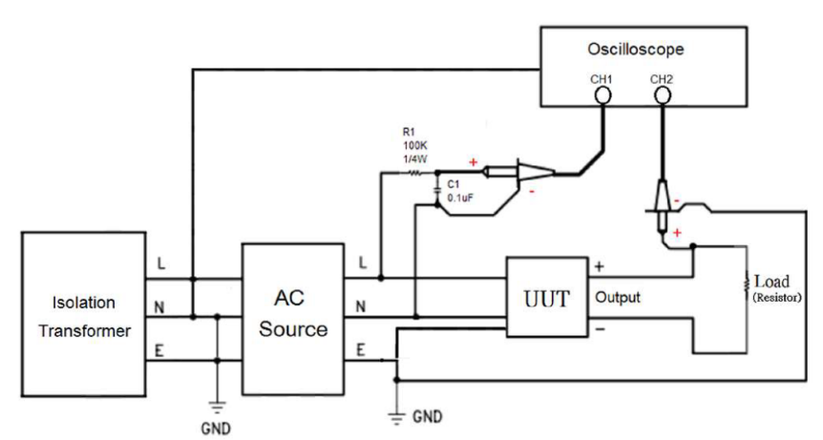

      - Primary to Secondary Ground:
The power supply shall have a 1 Meg Ohm 1/4W resistor and 0.1uF/100V capacitor parallel combination between earth ground (FG) and secondary DC ground.
      - ISN resistors:
The power supply shall have a 470 Ohm (minimum) resistor between earth ground (FG) and secondary DC ground.

    - Energy Efficiency
The device shall conform to the EPA Energy Star Requirements Level V for External Power Supplies:
      - The Average Active Mode Efficiency minimum (calculated by testing at 100%, 75%, 50% and 25% of rated output power and then computing the average of these four values) must be greater than the value specified in the table below at 115/230Vac input.
      - In addition the device must meet the No Load/Light Load requirements as specified below (measured at 115Vac/60Hz and 230Vac/50Hz):
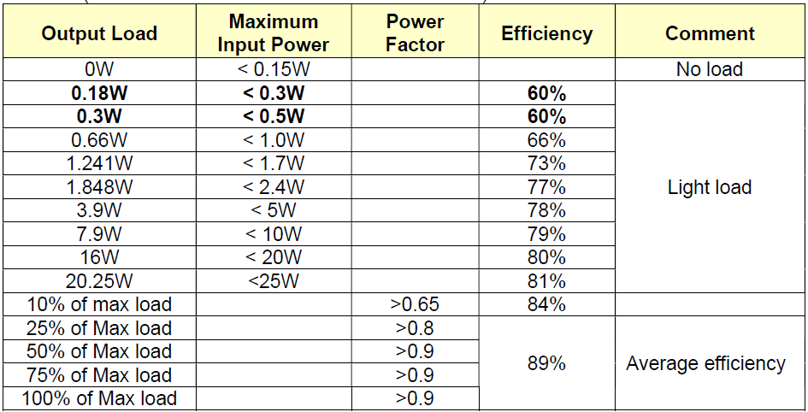

  - OUTPUT

    - Voltage
One (1) output shall be provided as defined and measured at the output connector of the supply: Output Voltage: 19.5V +-5%

    - Current
Min Load 0A Nom Load 8.46A Max Load 16.92A

Peak Load Condition:
Peak Load 23A (100ms max) – 16.9A (900ms) peak to 23A (100ms) > 18Vmin
Peak Load 32A (10ms max) – 16.9A (990ms) peak to 32A (10ms) > 18Vmin
Peak Load from 16.9A (500ms max.) to 23A (490ms max.)
Peak Load from 0A (700ms max.) to 23A (300ms max.)
Peak Load from 8A (700ms max.) to 23A (300ms max.)
Note: the output voltage will be allowed to drop to 18V minimum during this transient (measured at 90Vac and 264Vac).

    - Power
The power supply shall be capable of continuously supplying, when installed in the end use system, 330 Watts under all specified conditions.

    - Adapter Power Rating and ID
The power supply shall provide an “ADAPTER POWER RATING and ID” signal proportional to the output load current and output power rating power of 330 Watts. This signal communicates the AC Adapter power capability/rating and dynamic power draw from the AC Adapter. There shall be provisions to adjust the tolerance of the Power Rating. This signal should provide:
      - Two ID resistor, RID(100K) and RID2(110K)(in drain of 2N7002 or equivalent biased by a 200K and 100K to ground) shall be between the output voltage and the ID pin.
      - A high-level current source between 315W to 340W available at the ID pin.
      - At start-up when the output voltage is within its steady-state tolerance and at its rated load, or when the output current reaches 20% above its rated current, the “ADAPTER POWER RATING” signal shall start to become active after a delay of 50ms to 300ms.

    - Transient Response
(Step Load) The following transient loads are to be applied to the output. The frequency range of the transient loads described shall be from 1Hz to 5kHz. The waveform shall be a square wave with the slope of the rise and fall at 1 A/microsecond. The output voltage tolerance shall be allowed +5% / -5% during a step load change of up to 90% of full load including steps increasing from minimum or decreasing from full load. Varnishing or vacuum impregnation is required. Measurements should be made at output cable connector.

    - Output Regulation
At nominal input line voltage (120Vac), the output shall be subjected to the load described in Section 2.2.2, and shall remain within the regulation limits as defined in Section 2.2.1.

    - Protection
The power supply shall be automatically shut down under the conditions described below.

    - Over Voltage
The power supply shall provide over voltage protection such that under any single component failure, the output channel shall not exceed 29 volts with a maximum duration of 250 milliseconds.
(Latch mode)

    - Over Current
The power supply shall limit the maximum steady state output current to an average current of 25 Amperes. (Latch mode)

    - Short Circuit
The power supply shall be protected to latch such that a short from output to return shall not result in a fire hazard, shock hazard, or damage to the power supply. (Latch mode)

    - Outputs/Ripple/Noise
Maximum allowable peak-to-peak ripple and noise (as measured at the load with 100VAC input) on the output channel shall be 380mVpk-pk (or 250 mV RMS) ripple within 10 kHz to 20 MHz bandwidth. A resistive load (non-electronic) shall be used for this measurement. The output shall be bypassed to return by 1.0 microfarad ceramic capacitor in parallel with 10 microfarad tantalum capacitor at the point of load. The load cable shall be the specified output cable assembly. The printed wiring board assembly shall be installed in its enclosure for this measurement or have the measurement leads properly shielded and proper earth grounds applied to power supply.

    - Stability
The power supply shall be unconditionally stable while operating within its normal operating specification.

    - Overshoot
During power-on or power-off, the output voltage shall be monotonically increasing or decreasing with respect to the overshoot which shall neither exceed 21 volts peak nor be outside the regulation requirements for more than 10 milliseconds (mS).

    - Power-On Time
Output Regulation: The output (+19.5V) shall be in regulation within five (5) seconds after valid input power (90 VAC) has been applied.

    - Rise Time
Output Voltage: The output shall be in regulation within 40mS at 0 to 500mA condition. (Measured from 10% to 95% regulation)

    - Hold Up
- The power supply shall maintain voltage regulation within the specified limits in paragraph 2.2.1 for at least 5 milliseconds after loss of input voltage measured at 115 VAC and at maximum load.
- The power supply shall maintain voltage regulation within the specified limits in paragraph 2.2.1 for at least 10 milliseconds after loss of input voltage measured at 115 VAC and at 80% load.
.
    - Acoustic Test
The power supply when tested in an anechoic chamber shall not exceed the sound pressure levels per the HP AC Adapter Acoustic Noise Test Specification under all output load and ac input conditions. Acoustic noise measurements shall be conducted in accordance with ISO 7779 (or ECMA-74) and declared in accordance with ISO 9269 (or ECMA-109).

    - Thermal Shutdown
The power supply shall incorporate over temperature protection to prevent catastrophic failure from overheating.

- ENVIRONMENTAL REQUIREMENTS
  - TEMPERATURE

    - Operating
The supply shall operate from 0 to 35°C. The maximum temperature rise of any surface shall not exceed 45°C when measured at 100Vac and at maximum load.
- Measure adapter’s temperature on Bakelite
    - Non-Operating
The power supply can be stored from -20 to 85°C.
  - COOLING

The power supply shall be convection cooled only.

  - HUMIDITY

The power supply shall withstand without degradation with 95% relative humidity, non-condensing, both operating and non-operating.

  - ALTITUDE

    - Operating
The power supply can be operated at 5,000m above sea level.
    - Non-Operating
50,000 feet above sea level.

  - MECHANICAL SHOCK

(Power supply inside assembly.)
    - Operating
10 G, 11 ms, half sine, one shock input in each of three mutually perpendicular axes, for a total of six shock inputs.
    - Non-Operating
100 G peak, trapezoid, 180 in/s velocity change, one shock input per direction in each of three mutually perpendicular axes, for a total of six shock inputs. 240 G peak, 2 ms, half sine, one shock input in each of three mutually perpendicular axes, for a total of six shock inputs.
    - UL Safety
36-inch drop onto hardwood surface, after which no safety hazard is encountered regardless of operational capabilities.
    - Shipping
42-inch drop, all edges, surfaces — while enclosed in appropriate shipping container.

  - VIBRATION

(Supply inside assembly.)
    - Operating
0.75 G zero to peak, 5 to 500 Hz, 0.5 octaves/minute, one cycle, 5 to 500 to 5 Hz per axis in each of three mutually perpendicular axes.
    - Non-Operating
1.5 G zero to peak, 5 to 500 Hz, 0.5 octaves/minute, one cycle, 5 to 500 to 5 Hz per axis in each of three mutually perpendicular axes.
0.025 G squared/Hz, 10 to 500 Hz, nominal 3.5 G RMS level, one hour per axis, in each of three mutually perpendicular axes for a total duration of three hours.

  - ELECTROSTATIC DISCHARGE (ESD)
The AC adapter shall withstand ESD test voltage conditions at any point on the enclosure using the test setups and conditions found in Document 131296 and with transients as defined in IEC 61000-4-2. As an infrequently user touchable subassembly, the following test levels shall be used:
    - ±15 kV with no abnormal operation, but test to 20kV and report results
    - ±15 kV with no damage to power supply, but test to 20kV and report results
The storage capacitance shall be 150 pF and the discharge resistance shall be 330 ohms.

  - Production Line Hi-pot Test
One hundred percent (100%) of the AC Adapter shall comply with the minimum Production Line Hipot (High Potential) Test as noted below. The test shall be applied between the PRIMARY (AC LINE and NEUTRAL) to SECONARY (Vo and GND).

PARAMETERS | SETTING
VOLTAGE | 3000Vac Minimum
TRIP CURRENT SENSITIVITY | 10 mA Maximum
VOLTAGE RAMP TIME | 500 V/Second ramp Minimum
DWELL TIME | 1 Second Minimum

note:
The ROD-L DC Hi-pot Tester Model M100DC can be set to comply to the above test parameters.

  - ECO ENVIRONMENTAL
    - General Requirements
All products, components, and materials shall comply with the latest revision of HP Standard 011-00 General Specification for the Environment (GSE) including all referenced documents throughout the product life cycle.
Access to the public version of GSE is available from the URL. http://h20195.www2.hp.com/V2/GetDocument.aspx?docname=c04932490
    - Supplemental Environmental Specification
All commodity, component, and part materials shall comply with the HP Standard HX-00025- 01 Supplemental Environmental Specification – Commodity and Component (Supplemental Environmental Spec) requirements. Component categories are created to allow different material restriction requirements for each category. The Supplemental Environmental Spec is a supplement to the HP GSE.

The Supplemental Environmental Spec references the Substances and Materials Future Requirements (HX-00011-01A), Substances and Materials Business-Specified Requirements (HX-00011-01B) and Product Requirements (HX-00011-11) sections of the GSE with technical material and product specifications.

The product shall comply with all requirements in Supplemental Environmental Spec at the time of release, regardless of any future regulatory effective date.

The Supplier shall provide the required data to HP’s System Integrator for the completion of the HP Environmental Data Sheet (EDS), HP Recyclability Assessment Tool (RAT), and Disassembly Instructions.

Individual commodity or component specifications may exempt requirements to the Supplemental Environmental Spec as part of component-specific requirements, but otherwise the requirements in Supplemental Environmental Spec are applicable in all instances.

Low Halogen Exemption: Brominated and Chlorinated Flame Retardants; GSE section HX- 00011-01B; GSE Id 090807-92, & 080715-34, & 090807-37 AND Bromine and Chlorine in Printed Circuit Boards; GSE section HX-00011-01B; GSE id 080715-17, & 090807-66 AND Antimony; GSE section HX-00011-01B; GSE Id 110727-47 & 110727-63 are not required.

Access to the HP Commodity/Component Spec (HX-00025-01), Substances and Materials Future Requirements (HX-00011-01A), Substances and Materials Business-Specified Requirements (HX-00011-01B), and Product Requirements (HX-00011-11) require access to the HP Supplier Handbook, Restricted Access. Register or sign in from the URL.
https://h20168.www2.hp.com/supplierextranet/index.do

    - Other ECO Requirements
      - Energy requirements
      - Korea e-Standby (Energy Boy) (if applicable)
• System must com ply with Korea e-Standby Power Program Regulation on Standby Power Reduction. The detailed requirements can be found in the HP GSE - Product Requirements.
• Please note since this requirement is now mandatory by the HP GSE, it will be deleted in future releases of the product specification
      - Korea EPS-MEPS
• The External power supply must comply with the Korea Mandatory Energy Performance Specification (MEPS). The detailed requirements can be found in the HP GSE - Product Requirements.
• Please note since this requirement is now mandatory by the HP GSE, it will be deleted in future releases of the product specification.

      - Australia and New Zealand EPS Registration
• The External power supply must be registered in Australia and New Zealand. The detailed requirements can be found in the HP GSE - Product Requirements.

      - Accessibility
      - Section 508 Accessibility – US
The system must comply with the section 508 Accessibility – US requirements. Please reference: http://www.section508.gov/index.cfm?FuseAction=content&ID=12

      - EU Energy Related Products (formerly EuP)
        - Eup Lot 7
System must comply with EU regulation EU 1782/2019 for external power supplies. The detailed requirements will be found in the HP GSE – Product Requirements.

      - Belarus External Power Supply Certification
External power supplies must comply with energy efficiency standard STB 2463-2016.
The detailed requirements can be found in the HP GSE-Product Requirements.

      - Ukraine External Power Supply Certification
For products placed on market September 6th, 2020 and later: External power supplies must comply with Ukraine technical regulation No. 150. Detail requirements will be found in the HP GSE – Product Requirements.
Deliverables:
- In country certification of each EPS – Ukraine national statement of conformity(NSoC).
- Ukraine Conformity Mark on external power supplies.

      - NRCan (Canada) EPS certification and Registration
External power supplies must tested and registered according to Amendment 14, part 2 of the Canada energy efficiency regulation. The EPS must be certified by an accredited body and registered with the Canadian government by the supplier.
Deliverables:
- The external power supply must be marked with the roman numeral corresponding to the efficiency level met the international efficiency protocol (VI or higher).
- A signed report and certificate issued by an ISO/EN 17025 accredited laboratory showing compliance with this requirement.
- Confirmation of registration with the applicable Canadian government agency.

      - Mexico NOM-29
External power supplies must comply with the Mexico NOM-29 energy efficiency specification. Products must be tested for OFF mode at 127V/60Hz and labeled with the power consumption as required. The detailed requirements can be found in the HP GSE-Product Requirements.
Deliverables:
- In-country testing and certification of the EPS.

AGENCY APPROVALS
This product shall comply with all Regulatory requirements set forth in Hewlett Packard Specification 481605.
NOTE: EN60601-1-2 EMC MOOP [Design Compliance]
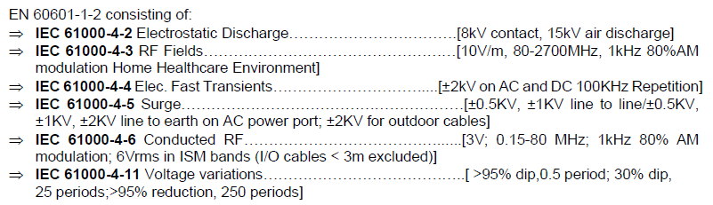

RELIABILITY
LIFE EXPECTANCY: The power supply shall have a field failure rate of less than 0.1% annually within the first three years of operation.
- De-rating Guideline
The following component de-rating requirements shall be followed:
- Semiconductor junction temperature shall be less than 130C
- Thermal De-rating at normal operation shall be <90%. Thermal measurements will be verified with the power supply mounted in a representative product enclosure. OTP shall not result in any damage and safety or reliability degradation. Need to meet HP Life time requirement is any load. Voltage and ambient temperature.
- Resistor power de-rating will be consistent with the resistor type and application.
- Component voltage de-rating shall be <95% for all continuous conditions
- Components shall not exceed 100% of their voltage rating during start-up and transients; exception: Bulk Capacitors shall not exceed 110% during transients.

- Component current de-rating shall be <90% for all continuous conditions. Exception: Bulk Capacitors shall not exceed 100% for all continuous conditions. The effects of ripple current heating shall be accounted for in this de-rating.
- All components shall be de-rating to insure meeting the calculated MTBF
- All magnetic devices shall be rated for 130C minmum
- All capacitors must be rated at 2000 hours or greater at maximum rated temperature, unless otherwise approved by HP. In any load, voltage and temperature, all capacitor must meet HP lifetime define.

- E-Caps life time
- All Aluminum electrolytic capacitors shall have a minimum lifetime of 8,736 hours at ambient temperature of 35degC and 80% Load.
- Usage profile 8h x 52 weeks x 3yrs = 8,736 hours
- E-Caps charge / discharge cycles
If the design presents operational modes where sustained regular repetitive heavy E-cap charge / discharge cycles are used, the supplier has to ensure that the E-caps are suitable for such use and that these charge / discharge cycles are within the components specification limits.
- Critical Components
The critical components list defines components with critical functionality, specifications, attributes, and parameters essential to the proper operation of the power supply and completed system. Once the list is complete for production, any deviation from this list requires documented completion of an agreed upon test plan. Final approval requires written HP acknowledgment. Due to the critical nature of these components, any deviation from the agreed upon BOM/AVL will jeopardize the stability, robustness and/or operation or the board. The timeframe for AVL proposals and finalization is described in the appropriate Statement of Work and schedule milestones. Specific application criteria for critical components are defined in Table 3.
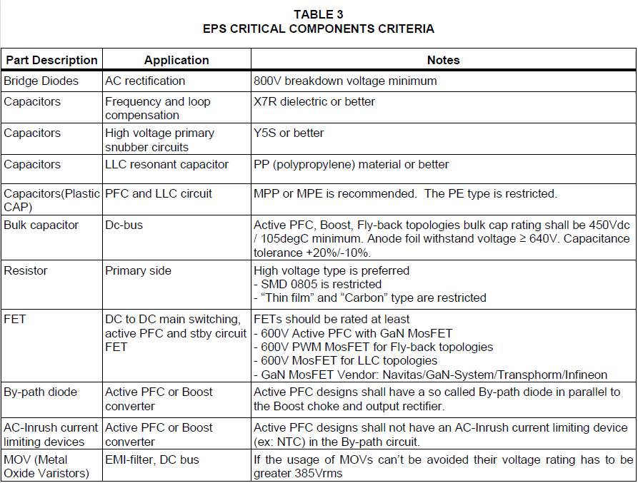
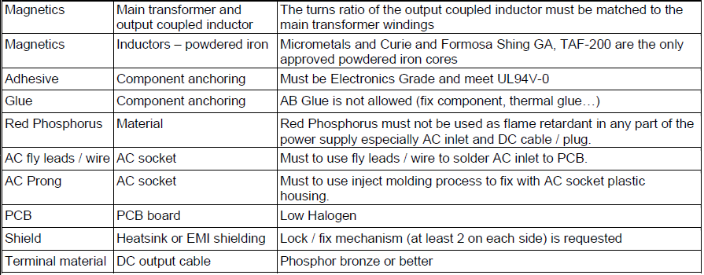
Mechanical characteristics
 | Item | Conditions |  |  |  |  |  |  |  |  | Specification
1. | Bending test | - Bead core - DC cord
1. | Bending test | Load | Angle (θ) |  | Arbitrary  direction |  | Cycles in every  minute |  | Sample size
1. | Bending test | 200 g | ±90° |  | 5000 Cycle |  | 40 Cycles |  | 5 Pcs |  | Disconnection rate of the wire shall be 30% or less, without damage to the insulations, etc..
1. | Bending test | DC plug over mold
1. | Bending test | Load |  | Angle (θ) |  | Arbitrary  direction |  | Cycles in every  minute |  | Sample size
1. | Bending test | 200 g |  | ±180° |  | 1000 Cycle |  | 40 Cycles |  | 5 Pcs | Disconnection rate of the wire shall be 10% or less, without damage to the insulations, etc..
1. | Bending test | 200 g |  | ±180° |  | 5000 Cycle |  | 40 Cycles |  | 5 Pcs | Disconnection rate of the wire shall be 50% or less, without damage to the insulations, etc..
1. | Bending test | 200 g |  | ±180° |  | Until broken |  | 40 Cycles |  | 5 Pcs
1. | Bending test | Case SR
1. | Bending test | Load |  | Angle (θ) |  | Arbitrary  direction |  | Cycles in every  minute |  | Sample size
1. | Bending test | 200 g |  | ±180° |  | 1000 Cycle |  | 40 Cycles |  | 5 Pcs | Disconnection rate of the wire shall be 20% or less, without damage to the insulations, etc..
1. | Bending test | 200 g |  | ±180° |  | 5000 Cycle |  | 40 Cycles |  | 5 Pcs | Disconnection rate of the wire shall be 100% or less, without damage to the insulations, etc..
1. | Bending test | 200 g |  | ±180° |  | Until broken |  | 40 Cycles |  | 5 Pcs
1. | Bending test | The test sample is hung by specified weight.  It shall be bent through angles of specified degrees in one direction, returned to its original position, then bent specified degrees in the opposite direction, after which it shall be returned to its original position to complete one cycle.  The rate flexing shall be specified cycle per min.
1. | Bending test | - DC Cable bending test need use HP Type C Bending test fixture, Detail setup see Below  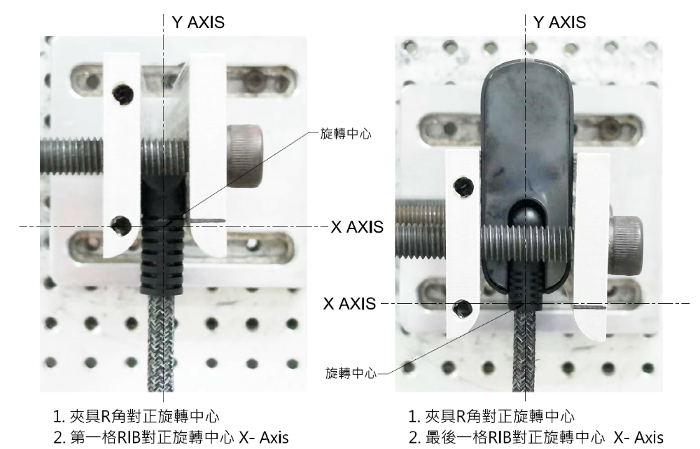
Item |  | Conditions |  |  |  |  |  |  |  |  | Specification
2. | Winding test | Only for horizontal side. 纏繞線材需完整的繞在CASE上  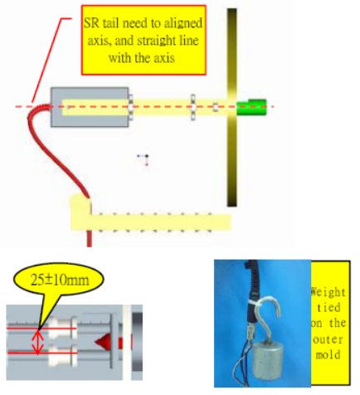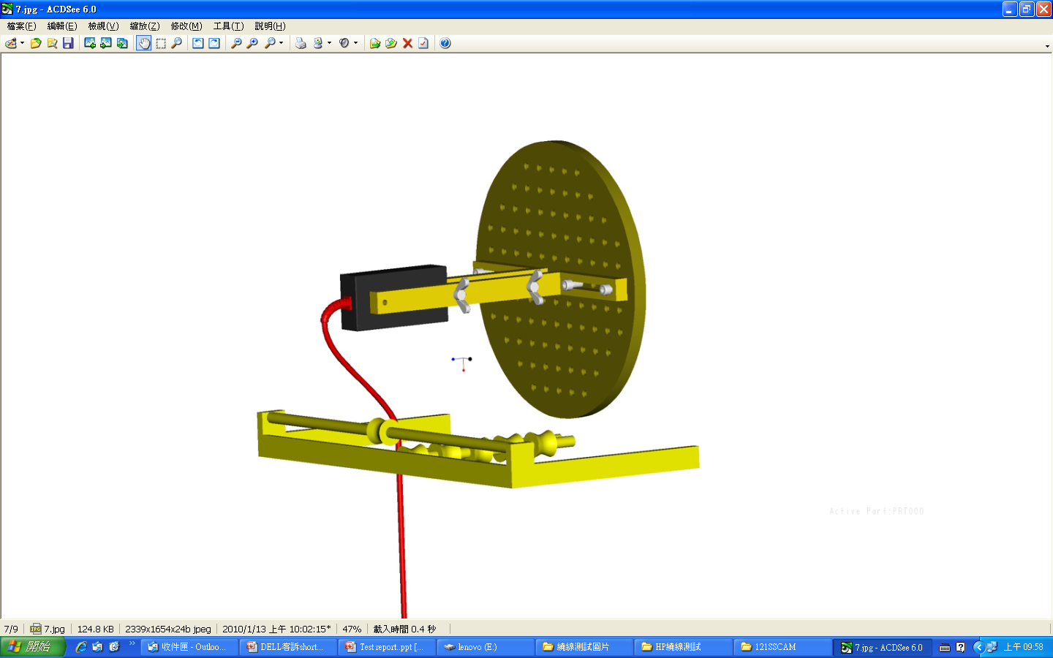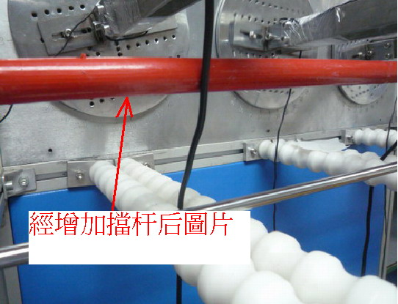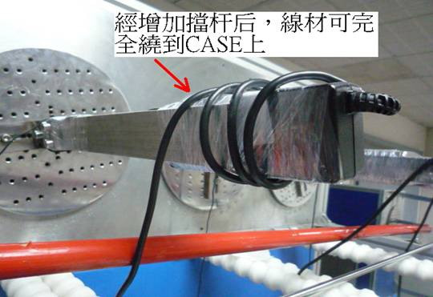  15~45˚  a straight li Cable tail and disk need to set it to the Axis center into ne  Winding Test SOP  1. Base on Test Condition to set up winding machine  ( for example frequency, the numbers and laps etc...).  2. Block width (25±10mm) Debugging machine. Then tested the cable tail.  3. PLUG out mold side going to bend and tie it up, then follow hang weights request to hanging to the out mold.  4. Make sure winding setting parameters, after confirm then going winding test.  5. After finish winding test，remove cable and dissection step by step. |  |  |  |  |  |  |  |  | Disconnection rate of the wire shall be 50% or less, without damage to the insulations, etc..
  Load | Angle (θ) | Arbitrary  direction | Cycles in every  minute | Sample size
  200 g | +/-1080° | 4000 Cycle | 2 Cycle | 3 Pcs
Item |  | Conditions |  |  |  |  |  |  |  |  | Specification
3. | Vibration | Only endurance conditioning by sweeping shall be made.  Operating  0.75 G zero to peak, 5 to 500 Hz, 0.5 octaves/minute, one cycle,  5 to 500 to 5 Hz per axis in each of three mutually perpendicular axes.  Non-Operating  1.5 G zero to peak, 5 to 500 Hz, 0.5 octaves/minute, one cycle, 5 to 500 to 5 Hz per axis in each of three mutually perpendicular axes.  0.025 G squared/Hz, 10 to 500 Hz, nominal 3.5 G RMS level, one hour per axis, in each of three mutually perpendicular axes for a total duration of three hours. |  |  |  |  |  |  |  |  | Output voltage  Follow Item 2.2.1
3. | Vibration |  |  |  |  |  |  |  |  |  | Dielectric strength：Without ignition smoke, damage, arcing or breakdown.
3. | Vibration |  |  |  |  |  |  |  |  |  | Insulation resistance ：100MΩ or more
3. | Vibration |  |  |  |  |  |  |  |  |  | Appearance：There shall be no blistering of the specification label or other damage to the construction.
4. | shock | Operating  10 G, 11 ms, half sine, one shock input in each of three mutually perpendicular axes, for a total of six shock inputs.  Non-Operating  100 G peak, trapezoid, 180 in/s velocity change, one shock input per direction in each of three mutually perpendicular axes, for a total of six shock inputs.  240 G peak, 2 ms, half sine, one shock input in each of three mutually perpendicular axes, for a total of six shock inputs. |  |  |  |  |  |  |  |  | Output voltage  Follow Item 2.2.1
4. | shock |  |  |  |  |  |  |  |  |  | Dielectric strength：Without ignition smoke, damage, arcing or breakdown.
4. | shock |  |  |  |  |  |  |  |  |  | Insulation resistance：100MΩ or more.
4. | shock |  |  |  |  |  |  |  |  |  | Appearance：There shall be no blistering of the specification label or other damage to the construction.
5. | Drop test | Delta Drop Test Standard for Portable Power Supply  Test height：1 meter for every surface(six sides) 1 times  Test surface material：hardwood surface or concrete |  |  |  |  |  |  |  |  | 1. Electrical characteristic  shall be satisfied.  2. PWB 銅箔無掀起或傷害  3. 無銲錫破損  4. 無零件破損  5. 若測試造成外殼  (Enclosure)裂縫,必須  Repeat test 5 times. 並進  行root cause analysis and  provide corrective action.  6. 測試Hi-pot為”PASS”  時,產品若有破洞, 裂縫  時需檢查User accessible  area與Hazardous voltage  parts,必須keep Double or  Reinforced insulation.
5-1 | Tumble test  (10000-0157-  0011) | - Drop height: 50 cm  - Tumble cycles: 5 Cycles  - Check function after 5 cycles |  |  |  |  |  |  |  |  | No major cosmetic  damage or less of  function.
6. | AC inlet insertion and withdrawal | DENAN-LAW：Rated load 5000 times, and rated load 1.5 folds/100 times (20 times/min.)  UL/CSA：Rated load 1.5 folds/250 times (10 times/min)  IEC：Rated load 1000 times, and without rated load 3000 times  (15 times/min.) |  |  |  |  |  |  |  |  | Without distinct damage in appearance.  Electrical characteristic shall be satisfied.
7. | AC inlet weight test | The plug shall be connected to AC inlet then direction of plug X and Y shall be applied to there condition.  Weight: 100 N. Time: 5 sec.  Test times: 3 times. |  |  |  |  |  |  |  |  | Without distinct damage in appearance.  Electrical characteristic shall be satisfied without solder crack of mounted board on AC inlet
8. | Ball impact | Delta Impact Test Standard for Portable Power Supply  1 The sample is placed on the laminated wood surface with the surface to be impacted positioned horizontally. If the sample needs to be stabilized or held in place, the stabilizing device must be solid to allow for the intended force to be delivered to the sample. For example, if blocks are used to support the samples, the blocks shall be secured together so that the sample sits securely and doesn’t move due to the impact delivered by the steel ball. The sample must be in contact with the laminated wood surface at all times.  2 The steel ball is allowed to fall freely from rest through the guide tube for a vertical distance of 1.3M to the point of impact.  3 Only one impact per sample shall be made. Use new samples for additional impacts. |  |  |  |  |  |  |  |  | 1. 若測試造成外殼  (Enclosure) 裂縫,必須Repeat test 5 times. 並進行root cause analysis and provide corrective action.  2. 測試Hi-pot為”PASS”時,產品若有破洞, 裂縫時需檢查User accessible area與Hazardous voltage parts,必須keep  Double or Reinforced  insulation.
9. | Acoustic Noise | Measurements to determine the AC adapter sound pressure are made using a 1/2” low noise free-field microphone in a inner size with 45(W)×45(D)×65(H) cm^3 Anechoic chamber. |  |  |  |  |  |  |  |  | Delta Spec.:  The AC Adapter shall produce no human perceivable audible noise (less then 25dB)  No load：< 22dB  0~Full Load:： 25dB
9. | Acoustic Noise | Position the microphone ten (10) centimeters above the x-y center of the AC Adapter.  Allow the AC adapter to warm-up for a minimum of 30 minutes prior to starting the test  Take a measurement with the AC Adapter configured for each of the test cases below:  No Load - 120Vac/60Hz  No Load - 240Vac/50Hz  Nominal Load - 120Vac/60Hz  Nominal Load - 240Vac/50Hz  Maximum Load - 120Vac/60Hz  Maximum Load - 240Vac/50Hz  10% Load - 120Vac/60Hz  10% Load - 240Vac/50Hz  Table – AC Adapter Acoustic Noise Levels |  |  |  |  |  |  |  |  | Pass/Fail Criteria  Please refer to the Table
  Frequency  (Hz) | Mag dBA  re 20 µPA |  | Frequency  (Hz) | Mag dBA  re 20 µPA
  630 | 5.0 |  | 4.00 k | 12.0
  800 | 7.5 |  | 5.00 k | 11.0
  1 k | 9.0 |  | 6.30 k | 10.0
  1.25 k | 12.0 |  | 8.00 k | 9.0
  1.6 k | 11.0 |  | 10.00 k | 8.0
  2.0 k | 12.0 |  | 12.50 k | 7.5
  2.50 k | 12.0 |  | 16.00 k | 13.0
  3.15 k | 12.0 |  | 20.00 k | 20.0
10. | Adhesion of specification labels | 1. Tape peeling test  2. High temperature storage  The AC adaptor shall be stored at a temperature of 65 ± 2℃  with relative humidity of 90% to 95% for 6 to 7 h  3. Low temperature storage  The d. c. power supply shall be stored at a temperature of -20 ± 3℃  for 6 to 7 h. |  |  |  |  |  |  |  |  | There shall be no blistering or peeling of the specification label.
11. | Wiggle test | 1. Fasten adapter and cord firmly to their plates.  2. Adjust motor cam shaft so that AC adapter is in max forward position.  3. Connect cord to AC power and adapter output cable to DC load with LED to indicate that power is on.  4. Adjust plate distance so that adapter and cord just make connection and LED is lit.  5. Adjust DC load to maximum load for adapter (65W adapter = 3.75A).  6. Let adapter thermally soak for 15-20 minutes.  7. Adjust Variac to ~30VAC (~750RPM) and run for ~10 minutes.  8. Adjust Variac to ~0VAC and adjust motor cam shaft so that AC adapter is in max forward position.  9. Adjust plate distance so that adapter and cord just make connection and LED is lit.  10. Repeat steps 7 through 9 until adapter receptacle contacts begin to produce audible arcing noises.  11. Repeat steps 6 through 9 except lower Variac operational voltage to ~20VAC (~300RPM) until adapter begins to produce consistently Long or loud popping and arcing noises.  12. Remove adapter and plug from plates and attempt to manually twist cord slightly while varying the insertion distance, attempting to produce prolonged arcing, If manual manipulation should begin to prove unproductive, return to fixture and repeat step 11.  13. There is a "test to failure" pass criteria. This means continue to execute this test procedure until the adapter no longer conducts or the test ends in smoke or melting. |  |  |  |  |  |  |  |  | 1. 如過程中有發煙,熔毀,停止後將樣品外殼拆開,觀察SOCKET後方如果Pin铆接處沒有晃動, 可判定為 ”PASS”, 如  SOCKET後方零件有被燒毀的現象,則判定為 ” FAIL”  2. 請注意卯接處發黑不是指塑膠熔毀後,覆蓋於卯接處的現象
13 | Outline dimension  Case Color | 200.0*90.0*25.4  BLACK |  |  |  |  |  |  |  |  | L x W x H  Color
14 | Weight | 770g+/-10% |  |  |  |  |  |  |  |  | XX g
15 | AC Inlet | C14 |  |  |  |  |  |  |  |  | C6 or C8 or C14 or CX Type
16 | DC Connector | Barrel Type  4.5*2.9*12.0 |  |  |  |  |  |  |  |  | X Type  O.D. x I.D. x L
17 | DC Cable Length | 1800+/- 50mm |  |  |  |  |  |  |  |  | XXXX mm
18 | Cap life | at ambient temperature of 35degC and 80% load |  |  |  |  |  |  |  |  | Minimum lifetime of 8760 hours  Usage profile 8h x 52 weeks x 3yrs = 8,760 hours
Product Application: NB
Product Ingress Protection (IP) rating: Not requirement (IP00).

